PGP INSTALLATION AND CONFIGURATION

Installation of PGP on a windows-based system.

Step 1: Firstly, download the OPENPGP
Step 2: Run as administrator to begin with installation.
Step 3: During installation select all the options below.
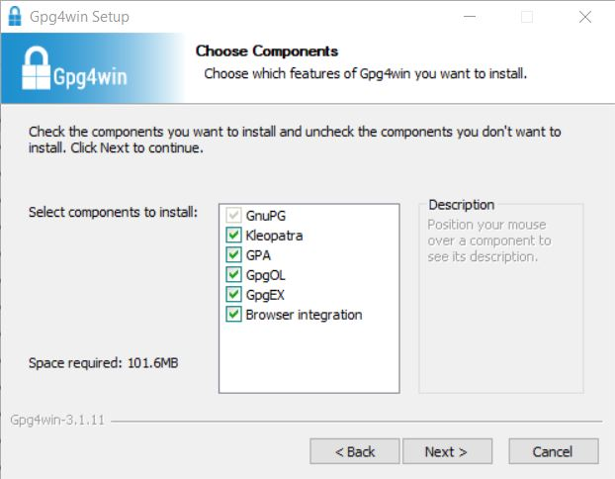

Creating Keys and configuration of your pgp account.
Step 4: Navigate to search for Kleopatra
Step 5: Select new pair of key. Find the welcome page for Kleopatra
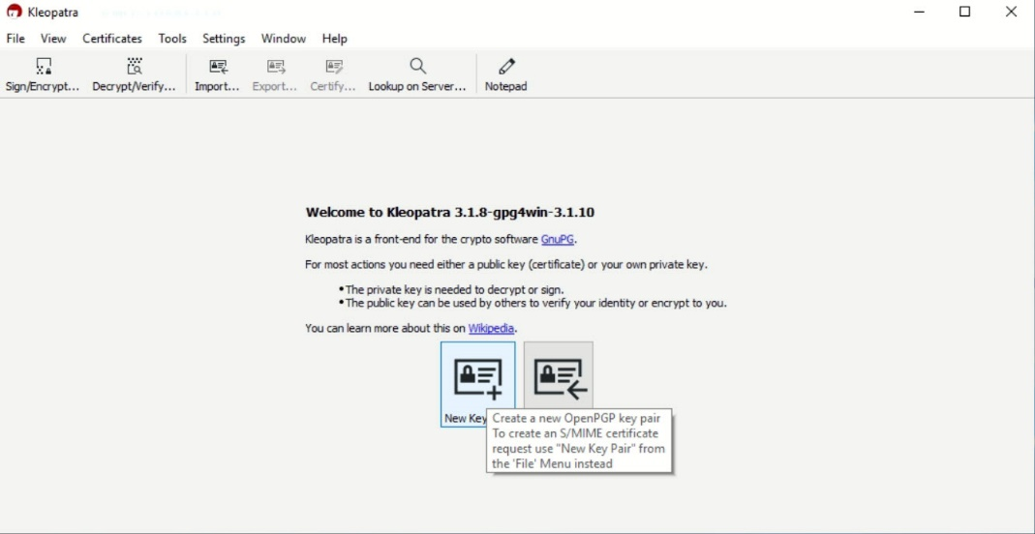

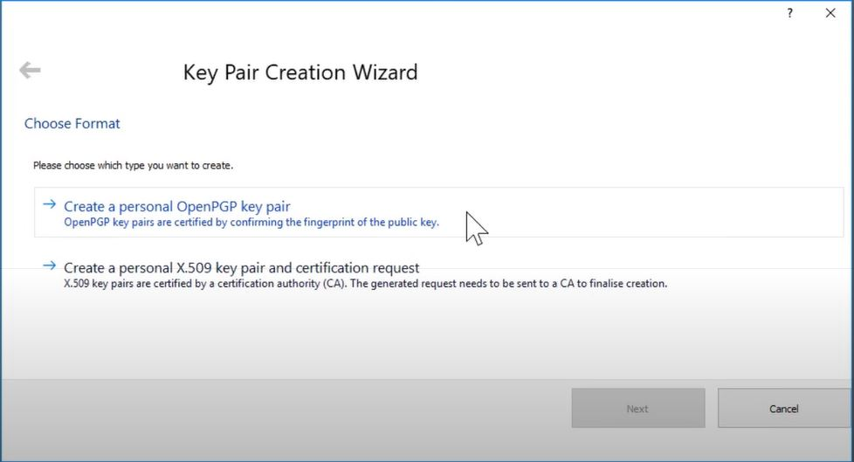

Step 6: Provide your Full name and email to be used for secure communication
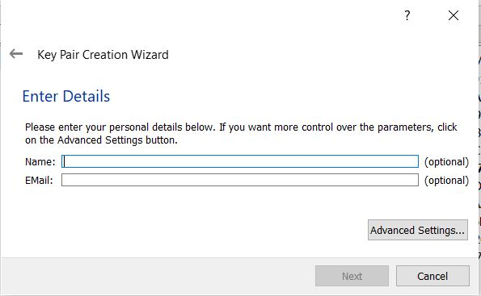

Step 7: Proceed to Advanced settings and select 4096 bits
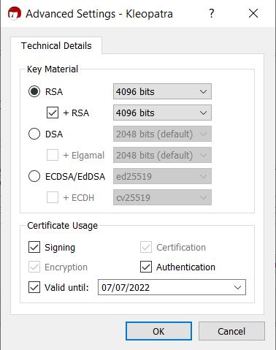

Step 8: Provide a passphrase to protect your secret key
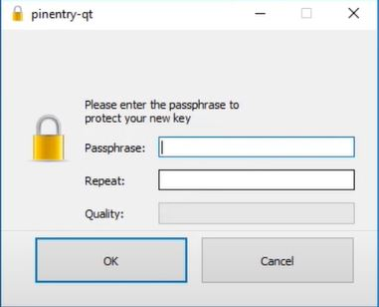

Step 9: Make backup of your key.
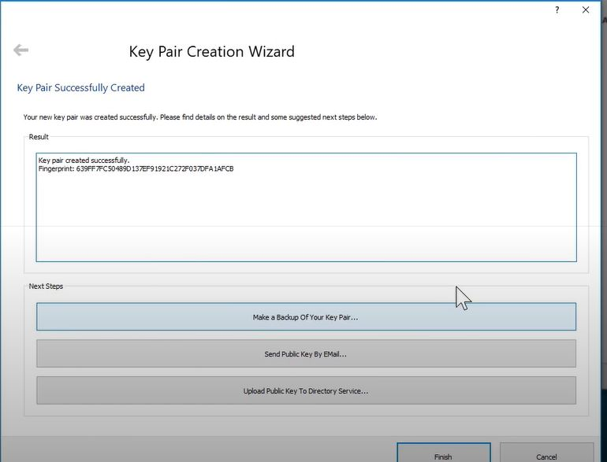

Signing others to have secure communications.

Step 10: Copy your public key by right your name on Kleopatra, scroll to Export, save it, open and copy it.

Step 11: Navigate to PGP.CIRCL to upload your previously copied public key and click on submit key. Paste and submit it.
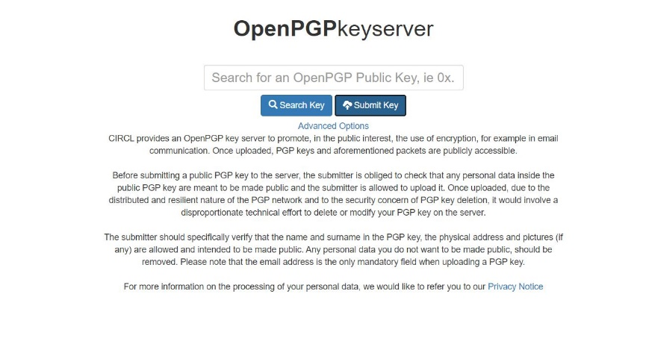
  - To sign others, navigate to PGP.CIRCL provide full name of that particular individual or their domain.
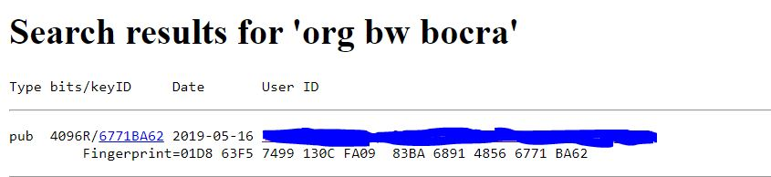

Step 12: Click on keyID (4096R/6771BA62), copy the public key.

Step 13: Go back to Kleopatra and paste on notepad

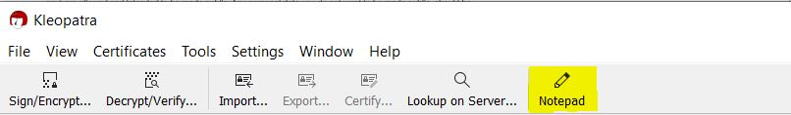

Step 14: Import Notepad
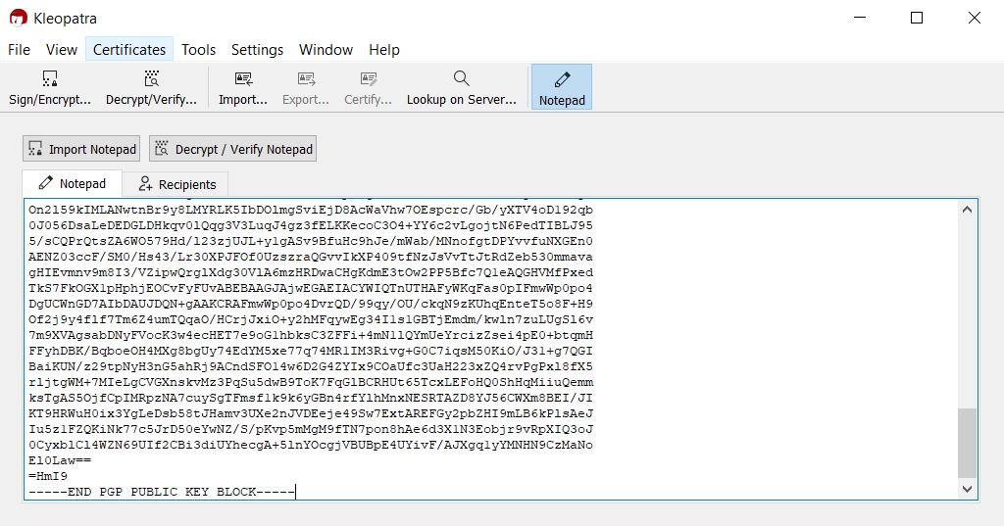
Step 15: Verify that the person you are signing is who they are by the following listed suggestions.
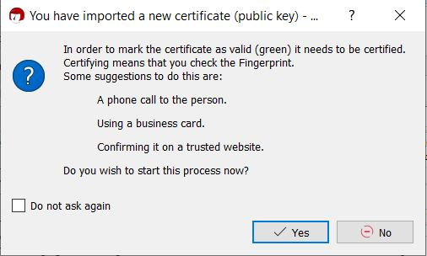

Start signing and encrypting communication on your outlook.

Step 16: Open your outlook application, then proceed to new email. Under Message click 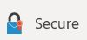 to activate both signing and encrypting.

Step 17: Now, provide content to your email like you normally do then send and input your passphrase.

Note: Have the best and secure communications from on forward.

